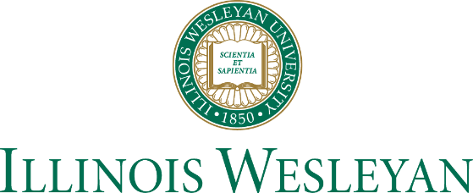

Study Abroad Peer Ambassador Program
2018-2019 School Year
International Office | Study Abroad

The IWU Study Abroad Peer Ambassador Program is an opportunity to share your global perspectives and study abroad stories, raise awareness and interest in study abroad programs, and inspire your peers and prospective IWU students to engage in diverse and inclusive cross-cultural learning experiences worldwide.
By serving as a Study Abroad Peer Ambassador, you will reflect on your time abroad in a meaningful way while developing concrete skills to articulate the value of your global experience in your personal, professional and academic endeavors. As an Ambassador, you will also strengthen your leadership skills and expand your networks at Illinois Wesleyan University and beyond.
Study Abroad Peer Ambassador responsibilities/assignments include but (but are not limited to):
- Participating in the Study Abroad Fair (September and January) and the International Education Week (November).
- Representing International Office at campus-wide events [i.e. prospective students’ open houses]
- Presenting in classrooms, club meetings, students’ panels and etc. to promote study abroad opportunities to a larger audience.
- Helping out during SA info sessions and pre-departure meetings.
- Leading a Study Abroad 101 workshop (30 minutes long typically), targeted towards international, first year students and everyone who is interested.
- Helping with social media and posters/flyers: post to your personal social media as well as to the Study Abroad FB page about upcoming events; hang up flyers.
- Recruiting other abroaders to help with various study abroad events.
- E-mail buddies: your contact information and words of advice will be added to our IWU Peer Ambassador web page so prospective students can reach out to you with questions.
- Drop-in hours: be available for one hour once a week at the Study Abroad Office. Students who have questions will be able to ask for advice in person!
- And other projects, depending on your interest and expertise.

Ambassador qualifications include:
- Maintain good academic standing.
- Available for two consecutive semesters.
- Be passionate about study abroad.
- Maintaining a professional demeanor and positive attitude regarding international experiences while representing IWU International Office.
- Possessing strong multi-faceted communication skills (writing, speaking).
- Reliability and accountability for overall responsibilities and timely correspondence with staff members.
BENEFITS OF BEING A STUDY ABROAD AMBASSADOR

Build Professional Experience
Learn More about International Education
Gain Valuable Skills [You will have the opportunity to sharpen your skills in leadership, public speaking, and communication among many others].
Free Study Abroad pin and a T-shirt
Certificate of Participation at the end of the academic year
YOU will get your own STAR! [Your photo will be displayed on the wall at the International Office as well as on our website].
Eligibility for THE AMBASSADOR of the Year AWARD
and
End of the Semester celebration!

